# Pin Layout

## NRF24L01+ (RF Module)

|  |  |
| --- | --- |
| NRF24L01+ | Motor shield |
| 1. GND | GND |
| 2. VCC | 3.3v |
| 3. CE | Digital 2 |
| 4. CSN | Digital 3 |
| 5. SCK | Digital 13 |
| 6. MOSI | Digital 11 |
| 7. MISO | Digital 12 |
| 8. IRQ | ----- |

## Line Tracking Sensors

|  |  |
| --- | --- |
| Line trackers | Motor shield |
| GND | GND |
| VCC | 5V |

|  |  |
| --- | --- |
| Line tracker 1 | Motor Shield |
| OUT | Analog 0 |

|  |  |
| --- | --- |
| Line tracker 2 | Motor Shield |
| OUT | Analog 1 |

|  |  |
| --- | --- |
| Line tracker 3 | Motor Shield |
| OUT | Analog 2 |

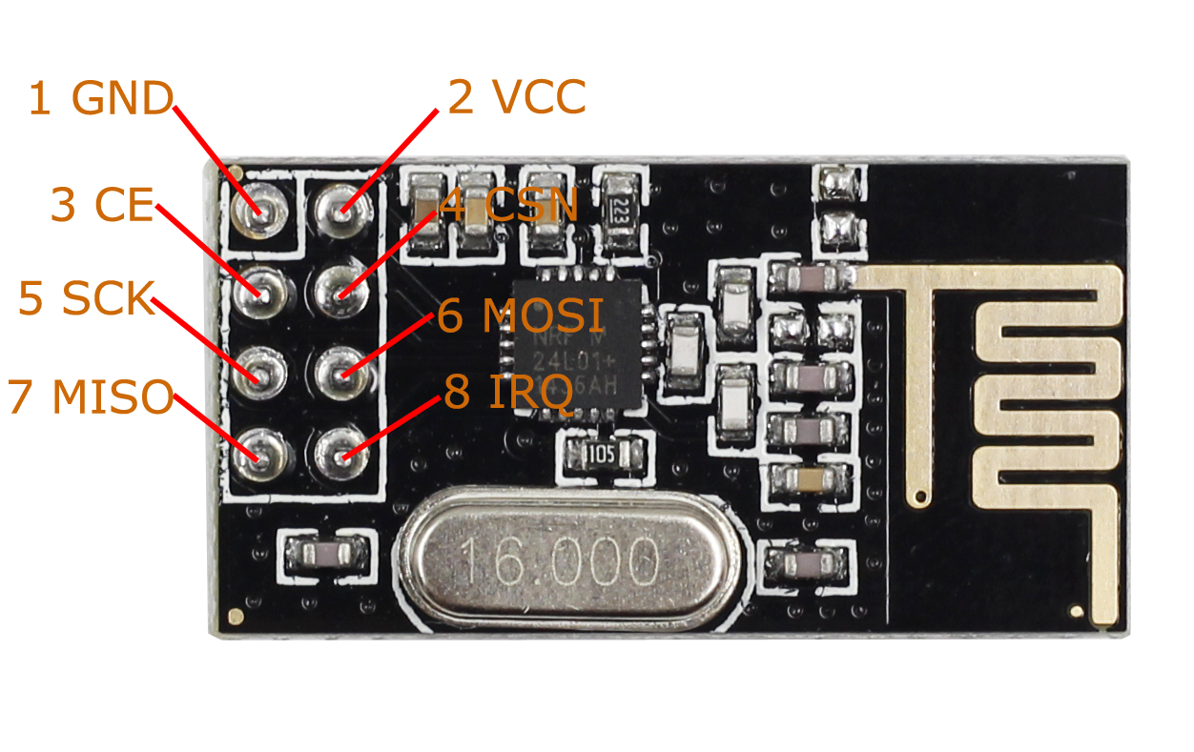

Afbeelding - NRF24L01+

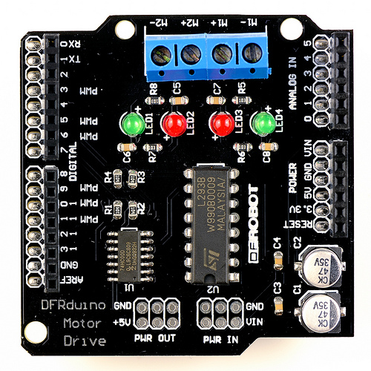

Afbeelding - Motor Shield